|  |  |  |  |
| --- | --- | --- | --- |
| **F:\Learning bugs\Foundation Subjects\Dolly the Fly - Science.jpgLyng Primary School Knowledge Organiser** | | | |
| **Topic: Science** | **Plants: growth and care**  **What do plants need to grow?** | Year 2 | Summer Term |



|  |  |
| --- | --- |
| **What Goldilocks and Step On words will I use?** | |
| **Spelling** | **Definition** |
| bulb | A rounded part of some plants that is under the ground. |
| condition | The state of something with regards to its appearance, quality or working order. |
| energy | The power that a plant uses. |
| flower | The colourful part of a plant. |
| germinate | When a seed starts to grow. |
| growth | The act of getting bigger. |
| leaf | The flat thin part of a plant that is attached to the stem and is usually green. |
| life cycle | The series of stages living things pass through. |
| nutrient | A food for plants which can be found in the soil. |

**Key knowledge**

**Notable Scientist:**

Joseph Banks was born in 1743. He was a particular type of scientist known as a 'botanist,' one who studies plants. His love of plants began at school and he always dreamed of travelling the world in search of new and different types of plants.

By the end of the unit, to know:

* Recall that seeds have all the necessary parts inside for plants to grow.
* Recall that seeds need water and warmth to germinate.
* Recognise that light is required for healthy plant growth.
* Sequence the stages of a plant’s life cycle.
* Recognise the importance of healthy plant growth.
* Describe the influences humans have on plants in the environment.
* Set up comparative tests.
* Plan observations and measurements.
* Use rulers to measure and record stem height.
* Record plant growth data in a table.
* Compare plant growth in different test conditions.
* Use a magnifying glass to observe and compare plants.
* Draw diagrams to represent stages of a plant’s lifecycle.

|  |
| --- |
| **Key questions - sequence of learning** |
| * What do seeds need to grow? * What is the difference between a seed and a bulb? * What do seeds need to germinate? * What effects how a plant grows? * What are the stages of a plant’s life cycle? * What do plants need to growth healthy? |

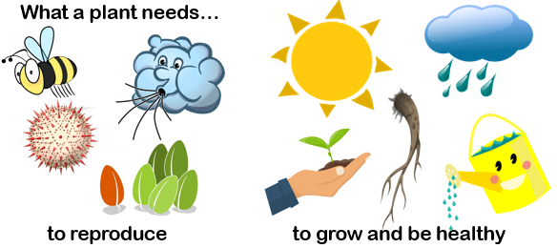

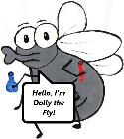

**What will I know by the end of the unit?**

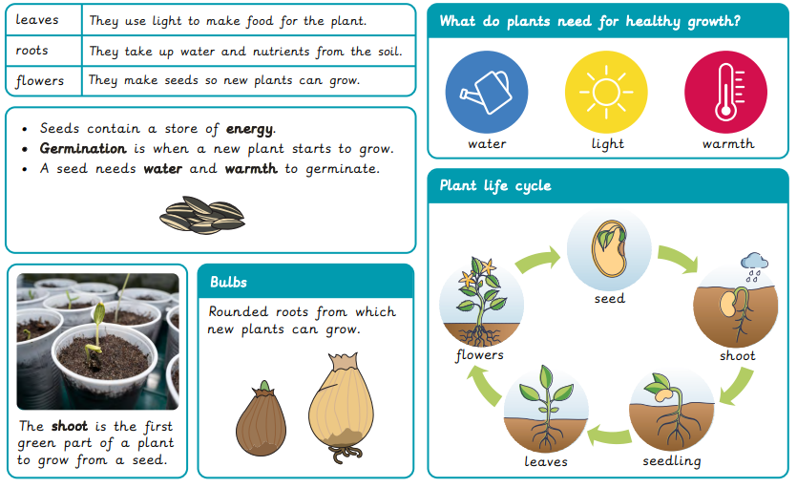

|  |  |  |  |
| --- | --- | --- | --- |
| **F:\Learning bugs\Foundation Subjects\Dolly the Fly - Science.jpgLyng Primary School Knowledge Organiser** | | | |
| **Topic:** | **Plants: growth and care**  **What do plants need to grow?** | Year 2 | Summer Term |

|  |  |  |  |
| --- | --- | --- | --- |
| 1. When a seed starts to grow it is called … | **S** | | **E** |
| bulb |  |  | |
| germinate |  |  | |
| produce |  |  | |
| nutrient |  |  | |

|  |  |
| --- | --- |
| 5. Draw and name four things a plant needs to grow healthily – one in each box. | |
| **Start** | |
|  |  |
|  |  |
| **End** | |
|  |  |
|  |  |

|  |  |  |
| --- | --- | --- |
| 2. The part of a plant that is under ground is called the ... | **S** | **E** |
| bulb |  |  |
| germinate |  |  |
| produce |  |  |
| nutrient |  |  |

|  |  |  |
| --- | --- | --- |
| 3. What is the purpose of leaves? | **S** | **E** |
| to anchor the plant |  |  |
| to produce food |  |  |
| to look pretty |  |  |
| to absorb the water |  |  |

|  |  |  |
| --- | --- | --- |
| 4. Which of these is a good condition for plants to grow? | **S** | **E** |
| outside in the fresh air, in a field with sunlight and rain. |  |  |
| On a windowsill in a house with no-one watering the plant. |  |  |
| In a school classroom, left over the summer holidays. |  |  |